EL GEZIRA RIDING ACADEMY

MAILING ADDRESS ONLY: 10952 Gallup Crossroads, Harpersville, AL 35078

PHYSICAL ADDRESS OF BARN: 96 El Gezira Drive, Harpersville, AL 35078

Pamela Ibrahim (205) 907-8300 - Cell

Dear Campers and Parents:

The 2019 camp season is fast approaching. We are looking forward to another fun-filled year. Days are filled with horse activities geared towards developing the knowledgeable horseman. Instruction twice daily in small groups insures rapid progress. Each camper is assigned a horse to groom and ride. All have the opportunity to improve riding skills, learn stable safety, grooming, saddling, feeding and training horses. It is through these activities that we have witnessed our campers developing important life skills. The atmosphere at a working barn promotes an understanding of the importance of being a hard worker, taking on responsibilities, time management and independence. Older campers who have attended over the years have become excellent role models for our younger campers. As counselors-in-training and eventual counselors, they develop one of the most important life skills – leadership.

Included in this packet is a full description of the riding camps, a map showing our location, lists of items to bring and suggestions made by past campers and parents. Also, you will find a release form, medical form, and enrollment form for you to fill out and return.

PLEASE READ EVERYTHING CAREFULLY!

Parents, these special rates apply:
- If more than one of your children attends the same camp, you will receive a $50 discount on the second child’s camp fee.
- If your child attends more than one camp, you will receive a $25 discount on the second camp.
- If you bring a horse to camp and you provide feed and hay, there is a charge of $60.
- If you bring a horse to camp and El Gezira provides feed and hay, there is a charge of $60 plus $10 per day.

Campers with no riding experience will be required to obtain some lessons prior to the camps. Past experiences have taught us this is necessary for the campers to be able to join in horse activities safely and enjoyably. Please contact me to make arrangements for these lessons.

Availability for camp is on a first come, first served basis. To reserve your place, return a deposit of $100 per camper with your camp forms.

PLEASE SEND DEPOSIT, ENROLLMENT FORM, MEDICAL FORM AND RELEASE FORM TO:

Pam Ibrahim
10952 Gallup Crossroads
Harpersville, Alabama 35078

See you soon!

Pam Ibrahim

Spring Break DAY CAMP is 9 am to 3 pm with drop off before & pick up after.
Summer Camps begin between 4 and 5 p.m. on Sunday.
Camp orientation begins at 5 p.m.

2019 CAMP DATES

DATES CAMP ARRIVAL DEPART HORSE SHOW CAMP FEE

March 27th –  March 29th | Spring Break  “Day-Camp” | Daily Arrival,  Before 9 am | Daily Pick-Up  After 3 pm | Camp Program  On Friday  (No horse show) | $225
June 2nd – June 8th | SUMMER  CAMP I  Beginner/  Intermediate | Between 4 and 5 pm,  Sunday,  June 2nd | Saturday, June 8th | June 8th  8 am Camp Awards  9 am Schooling Show | $600
June 16th – June 22nd | SUMMER  CAMP II  Beginner/  Intermediate | Between 4 and 5 pm,  Sunday,  June 16th | Saturday,  June 22nd | June 22nd  8 am Camp Awards  9 am AHJA Show | $600
July 14th – July 20th | SUMMER  CAMP III  Intermediate/  Advanced | Between 4 and 5 pm,  Sunday,  July 14th | Saturday,  July 20th | July 20th  8 am Camp Awards  9 am AHJA Show | $600
Campers are encouraged to participate in the Schooling Show on June 8th and the two AHJA sanctioned Horse Shows on Saturday June 22nd and July 20th.

Horse Show fees are NOT included in the camp fee and will be due at the show.

Plan to arrive at SUMMER camp on the day camp begins between 4 and 5 pm.

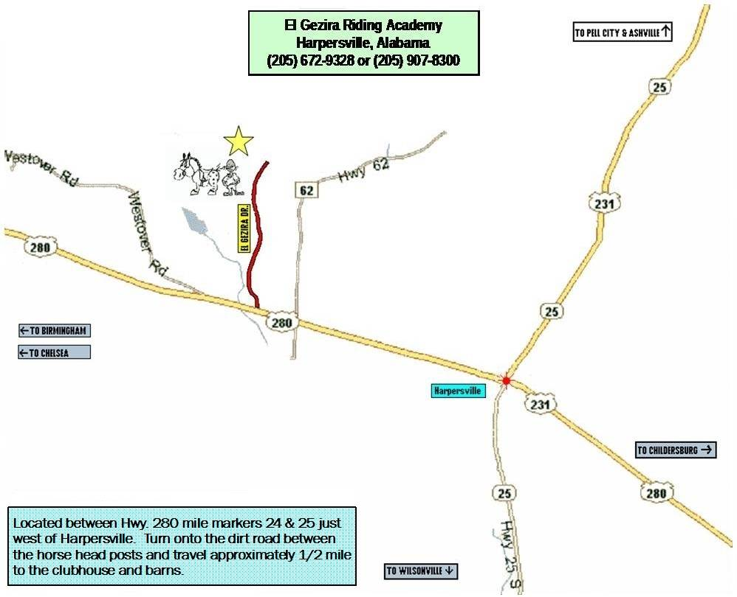

ITEMS YOU WILL NEED FOR CAMP:

Please check this list before leaving home.

- Personal toiletries - soap, shampoo, toothpaste, toothbrush, comb/brush, etc.
- Pillow, sleeping bag or other bedding.
- Riding clothes for camp – riding pants or tights, shirts, riding helmet, boots. All campers must wear a riding helmet and boots when mounted. No tennis shoes allowed when mounted.
- Riding clothes for show – plain white shirt or riding shirt, riding breeches, and proper footwear. Please ask Pam if you are unsure about show clothing.
- Play clothes and shoes (more than one pair)
- Raingear – raincoat or poncho, rubber boots
- Swimsuit and a beach towel. Weather permitting; we will be swimming in our pool at night.
- Sleepwear
- Sunscreen
- Non-aerosol Bug spray
- Towels & Washcloths
- Medications
- Intermediate/Advanced campers should bring money for a trip to the cinema one night and pizza one night.
- Understanding about our policy on phone calls to/from home during camp. Because we are promoting responsibility and self-reliance, campers will be making one short call home during the week and, if parents do need to call, please talk with the counselors first.

SUGGESTIONS AND ITEMS YOU MIGHT LIKE TO BRING:

- Snacks – We provide all meals, snacks and drinks but campers are allowed to bring their own snacks and drinks. In fact, most campers choose to do so. We do have limited space for storage and you will need to label all items with permanent marker.

- There is limited space for storage of your camp items at the end of each bunk but if you can provide containers 11 inches high or less, there is more space under the bunks.

- You will not need makeup, curling irons or blow dryers. The horses love the natural look!! Time in the bathrooms is limited and the heat generated by blow dryers makes the clubhouse unbearable.

- You might like to bring added support and comfort for the bunk beds. Foam egg crate mattress pads have been a favorite in past years.

- Keep in mind that this is an active camp and you will get dirty and muddy. Old clothes and shoes will make your stay more enjoyable.

- A reasonably priced rubber boot can be found at Wal-Mart and other discount stores.

- If you can avoid wearing new riding boots and/or can bring another boot or shoe to change into during the day, you will be less likely to get blisters.

- Although we will not be washing all of the campers clothing, we do have a clothesline for bathing suits, beach towels, bath towels, etc. We will help the campers if they need clean clothes but we won’t be able to wash all clothing. Please keep this in mind when you are packing.

DO NOT BRING:

- CELL PHONES!!!!!!! (Should you forget and bring your phone, it will be collected and returned to you at the end of camp.)
- Electronic Games
- Bikes, Scooters, etc.

EL GEZIRA RIDING ACADEMY
Presents

2019 RIDING CAMPS

El Gezira Riding Academy’s Riding Camp program is a unique learning experience in the horse world. Our Academy is equipped with a covered riding arena, sleeping quarters, swimming pool, and of course, horses!! Campers partake in daily riding lessons, lectures on horsemanship and stable management, swimming and fun. We stress total horsemanship, which requires total care of the horse. Campers are required to participate in all aspects of horse care.

We have specialized camps to suit the needs and abilities of our wide range of riders. Each camper is offered the opportunity to improve his or her riding and horsemanship skills while working towards a Certificate of Achievement. The requirements for each Certificate are:

Beginner:
- Lead horses,
- Groom properly ,
- Tack up/untack,
- Mount/dismount,
- Clean tack,
- Adjust stirrups,
- Know twenty parts of the horse and five parts of tack,
- Walk, trot, canter,
- Know diagonals and leads,
- Jump an 18” course or score 60% or higher on a Walk/Trot dressage test and
- Earn one perfect inspection score.

Intermediate:
- Know all parts of the horse and tack including bits,
- Know horse care including grooming, proper hoof care, pulling manes, use and care of clippers, feeds, supplements, worming and vaccinations,
- Set up simple cavelleti exercises,
- Basic lunging skills,
- General understanding of loading/unloading trailers,
- Basic stable management skills including cleaning stalls correctly,
- Jump a 2’6” course proficiently or score 60% higher on a Training Level dressage test and
- Earn three perfect inspection scores
- Display characteristics of a good horseman – shows responsibility toward all aspects of horse care, shows initiative to help others, and is a good example to others...

Advanced:
- Lunging/driving skills,
- Wrapping legs for training, trailering or injury,
- Basic first aid including injections,
- Set up simple gymnastics,
- Groom horse for show including braiding and body clipping,
- Teach beginner and intermediate lessons, give beginner and intermediate camp lectures, instruct camp drill team,
- Understand basic course design,
- Jump a 3’3” course proficiently or score 60% or higher on a First Level dressage test,
- Earn one week of perfect inspection scores, and
- Excel in all areas of stable management including the ability to meet the needs of students, boarders and clients.
- Displays characteristics of an excellent horseman – shows maturity, can make wise decisions concerning horses and riders, can respond to equine emergencies, takes on responsibilities, and is an excellent example for all to follow.

Instructor:
- The above requirements,
- Good teaching skills for all student levels,
- Develop and implement lesson plans for all student levels,
- Start and train young or green horses,
- Work productively with problem horses,
- Course designing for all levels,
- Set up dressage arena,
- Show management skills, and
- Ride/show at 3’6” level or score 60% or higher on a Second Level dressage test.

We have had many students receive their beginner certificates and continue on through the intermediate level. We hope these students will set their sights on achieving their advanced certificates.

As a grand finale, we host a horse show at the end of the summer camps. Summer camp awards presentation begins at 8 a.m. followed by the horse show at 9 a.m. The show gives the campers an opportunity to showcase their progress made during the camp. Horse Show fees are not included in the camp cost and will be provided to parents of campers only. Parents, you don’t want to miss it!!

SEE YOU AT CAMP!!

EL GEZIRA RIDING ACADEMY
2019 CAMP ENROLLMENT FORM

Camp availability is on a “first come first serve” basis. Please remember to enclose a deposit of $100 per camper with your enrollment form and release form to reserve your place. BE SURE TO CHECK WHICH CAMP YOU WISH TO ATTEND.

I will
ATTEND
(Check) DATES CAMP HORSE SHOW***** FEE

 | March 27 – March 29 | SPRING BREAK DAY CAMP | Camp program on  Friday  (No horse show) | $225
 | June 2 – June 8 | SUMMER CAMP I –  Beginner/Intermediate | June 8  8 am Camp Awards  9 am Show | $600
 | June 16 – June 22 | SUMMER CAMP II –  Beginner/Intermediate | June 22  8 am Camp Awards  9 am Show | $600
 | July 14 – July 20 | SUMMER CAMP III –  Intermediate/Advanced | July 20  8 am Camp Awards  9 am Show | $600
*****Show fees are NOT included in the camp fee
Camp orientation begins at 5 p.m.

NAME OF CAMPER: __________________________________________________________ AGE: ____________________
NAME OF PARENT OR GUARDIAN: ______________________________________________________________________
E-MAIL ADDRESS: _____________________________________________________________________________________
ADDRESS: ____________________________________________________________________________________________
HOME PHONE: ______________________________WORK PHONE: ____________________________________________
CELL PHONE: ___________________________________

CAMPER’S RIDING ABILITY: Please get with the camp director if you are unsure of your camper’s riding abilities!!

_____Beginner
_____Intermediate (good basic riding skills)
_____Advanced (very good riding skills and horsemanship)

ADDITIONAL INFORMATION we should know about this camper: _____________________________________________
_____________________________________________________________________________________________________

PLEASE CHECK ALL THE FOLLOWING THAT APPLY TO YOU:

_____I will bring my own horse and pay an additional $60. I will bring feed and hay.
_____I will bring my own horse and pay an additional $60 plus $10 per day and El Gezira will provide feed and hay.
_____I am enclosing a check or money order in the amount of $_________ for my deposit.
_____I am enclosing a check or money order in the amount of $_________ for the entire camp tuition.
_____I have made other arrangements with the camp director.

SEND ENROLLMENT FORM, DEPOSIT AND RELEASE FORM TO:
Pam Ibrahim, 10952 Gallup Crossroads, Harpersville, AL 35078 -- (205) 907-8300

EL GEZIRA RIDING ACADEMY

MEDICAL FORM

All medications will be held and administered by camp personnel.
All medications must be labeled with camper’s name, medication name, and dosage.

NAME: ______________________________________________________________

PARENT(s) OR GUARDIAN(s) NAME: ______________________________________________
Can be reached at: ________________________________________________________________
Alternative emergency contact: ______________________________________________________
________________________________________________________________________________

NON-PRESCRIPTION MEDICATIONS:

I request that the following non-prescription medications be administered to my child as needed for:

Reason Medication Dosage Amount Dosage Times

Parent or Guardian Signature: ______________________________________

PRESCRIPTION MEDICATIONS:

I request that the following prescription medications be administered to my child as needed for:

Reason Medication Dosage Amount Dosage Times

Parent or Guardian Signature: ______________________________________

OTHER MEDICAL INFORMATION (allergies, etc.) ________________________________________________________________________________________________________________________________________________________________________________________________________________________________________________________________________________________________________________________________________________

Release and Waiver of Liability and Indemnity Agreement

This RELEASE and WAIVER of LIABILITY and INDEMNITY AGREEMENT is made and entered into on this _________ day
of _________________, 20___, by and between EL GEZIRA RIDING ACADEMY a/k/a SPRING VALLEY FARMS (hereinafter designated "EGRA"), and ______________________________________ (hereinafter designated "Rider"), and if Rider is a minor, Rider's parent or guardian, _____________________________________, In return for the use, today and on all future dates, of the property, facilities and services of EGRA, the Rider, his heirs, assigns, and legal representatives, hereby expressly agree to the following:

I. It is the responsibility of the Rider to carry full and complete insurance coverage on himself, his personal property and, if applicable, his horse.

2. Rider agrees to assume ANY AND ALL RISKS INVOLVED IN OR ARISING FROM THE RIDER'S USE OF OR PRESENCE UPON EGRA 'S PROPERTY AND FACILITIES including, but not limited to, the risks of death, bodily injury, property damage, falls, kicks, bites, collisions with vehicles, horses or stationary objects, fire or explosion, the unavailability of emergency medical care, or the negligence or deliberate act of another person.

3. Rider agrees to hold EGRA and all of its successors, assigns, subsidiaries, affiliates, officers, directors, employees, and agents completely harmless and not liable and release them from all liability whatsoever and AGREES NOT TO SUE them on account of or in connection with any claims, causes of action, injuries, damages, cost or expenses arising out of Rider's use of or presence upon EGRA's property and facilities, including without limitation, those based on death, bodily injury, property damage, including consequential damages, except if the damages are caused by the direct, willful and wanton negligence of EGRA.

4. Rider agrees to waive the protection afforded by any statute or law in any jurisdiction whose purpose, substance and/or effect is to provide that a general release shall not extend to claims, material or otherwise, which the person giving the release does not know or suspect to exist at the time of executing the release.

5. Rider agrees to indemnify and defend EGRA against, and hold it harmless from, any and all claims, causes of action, damages, judgments, costs or expenses, including attorney's fees, which in any way arise from the Rider's use of or presence upon EGRA's property and facilities.

6. Rider agrees to abide by all of EGRA's rules and regulations.

7. If Rider is using his horse, the horse shall be free from infection, contagious or transmissible disease. EGRA reserves the right to refuse horse if not in proper health or is deemed dangerous or undesirable.

8. This contract is non-assignable and non-transferable and is made and entered into in the State of Alabama and shall be enforced and interpreted as broadly and inclusively as Permitted by laws of the State of Alabama. Should any clause herein be in conflict with State Law, then that clause is null and void but the balance of the contract shall continue in full legal force and effect. When EGRA and Rider or Rider's parent or guardian if Rider is a minor, sign this contract, it will then be binding on both parties, subject to the above terms and conditions.

WARNING: Under Alabama, law, an equine activity sponsor or equine professional is not liable for an injury to or the death of a participant in equine activities resulting from the inherent risks of equine activities, pursuant to the Equine Activities Liability Protection Act.

______________________________________________________
Signature of EGRA Representative

______________________________________________________
Signature of Rider or Rider's Parent or Guardian (if Rider is a minor)

________________________________________________________________________________________________
Rider's Address and Phone Number

